Phone: 5152 4662 Date: 26.11.2025

Email: lucknow.ps@education.vic.gov.au Website: www.lucknow-ps.vic.edu.au
Students and staff at Lucknow Primary School acknowledge the Gunai Kurnai people of the Brabuwooloong land in which our school stands. We pay our respects to their Elders past, present and emerging.


WEEKLY EVENTS
MONDAY | TUESDAY | WEDNESDAY | THURSDAY | FRIDAY
- Active Allstars with Mr Hudson 8:15-8:45am. Meet at the top gate near the Playground |  | - Breakfast Club in the Hall 8:15am – 8:30am  - Active Allstars 8:15-8:45am  - Play2Learn Playgroup in the Library 9:15 -11:00am | - Breakfast Club in the Hall 8:15am – 8:30am | - Walk to School 8am. Meet at the corner of Flynns Rd and the Highway or join along the way!

SCHOOL CALENDAR –Term 4 2025
MONDAY | TUESDAY | WEDNESDAY | THURSDAY | FRIDAY
NOVEMBER 24 | 25 | 26 | 27 | 28
- Grade 5 & 6 Water Safety Program 9:00am – 3:30pm |  |  |  | - Prep 2026 Transition #3 9-10:30am  - Assembly 2:25pm  - Book Club orders due
DECEMBER 1 | 2 | 3 | 4 | 5
- Open Afternoon Learning Celebrations 3:00-4:30pm | - Nagle College Orientation Day | - Whole School Transition #1 11:30 - 1:30PM | - Gr 4 & Gr 3/4 Melb Museum excursion | - Parent Requests for Reports Due  - Whole School Transition #2 including 2026 Preps  9 – 11am
8 | 9 | 10 | 11 | 12
- Whole School Christmas Concert | - Bairnsdale Secondary College transition day #1  - Whole School Transition #3 including 2026 Preps 9 - 11AM | - Bairnsdale Secondary College transition day #2 |  | - Celebrating Student Leaders and 2026 leader announcement Assembly 2:20pm  - Reports available on uEducateUs
15 | 16 | 17 | 18 | 19
- Grade 6 Gumbuya World Celebration | - Grade 6 Graduation 9am  - Class parties | - Last official day for students  - Whole School Award Assembly 9am

PRINCIPAL’S REPORT
Planning for 2026
Staff have been hard at work finalising student placements for 2026 and adding the finishing touches to next year’s classes. It’s an exciting time of year as we prepare for our first school-wide transition sessions next week!
Please take note of the transition session dates and times below so your child is ready for this important step.

Wednesday 3rd Dec: Whole School Transition #1
11:30am - 1:30pm
Friday 5th Dec: Whole School Transition #2
9:00am – 11:00am
Tuesday 9th Dec: Whole School Transition #3
9:00am – 11:00am
Events
There are plenty of exciting events and excursions coming up as we head into the final weeks of the year. It’s a busy and vibrant time for our school, with lots of opportunities for students to celebrate the school year and their achievements. Please take a moment to check the calendar so you don’t miss any of these important dates!

You may be feeling busy — and even a little overwhelmed — as we approach the end of the school year and Christmas edges closer. It’s a hectic time for everyone. Please remember to be kind to yourself and to others. And if you need support in any way, don’t hesitate to reach out — we’re here to help.

Happy learning everyone!
Carly Miller – Principal

END OF YEAR CELEBRATION ASSEMBLIES
This year, School Council has approved a new approach to our end-of-year celebrations. Rather than one extended assembly, we will be holding two shorter celebration assemblies, each highlighting different aspects of student leadership, learning and growth.

Celebration Assembly 1 – Friday 12th December, 2:30pm
Our first assembly will recognise and congratulate our emerging and current student leaders, featuring:
• Announcing our 2025 Junior School Council representatives
• Acknowledging our 2025 Student Leadership Team
• The exciting reveal of our 2026 Student Leadership Team

Celebration Assembly 2 – Wednesday 17th December, 9:00am
Our second assembly will focus on individual and group achievements across the school, including:
• Representing Grade 6 Awards
• Grade 5 Freemason Scholarship recipients
• Attendance, Academic Achievement and Growth Awards
• A warm farewell to our Grade 6 students and staff moving into their next chapter

We look forward to celebrating the dedication, progress and leadership demonstrated by our students throughout the year and warmly invite our school community to join us for these special events.

Emily Forbes - Assistant Principal

ROTARY
23 Lucknow PS students attended the Junior Community Rotary Award presentation night alongside Miss Szabo and Sylvana last week. Multiple other schools were there to receive their awards also.

Cooper, Nate and Maxynne did an incredible job speaking on behalf of the Lucknow students.

Well done and thank you to all students, families and friends involved. The students should be extremely proud of their achievements!
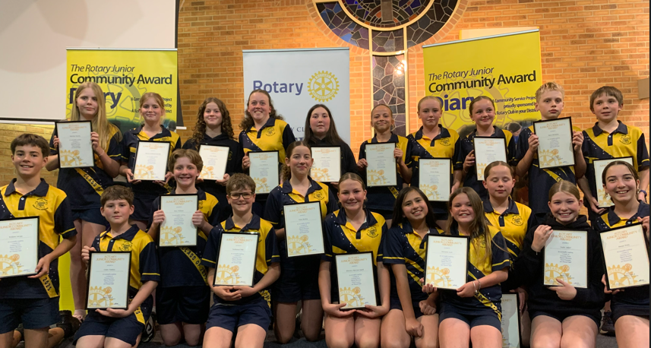

VOLLEYBALL
Last Friday our amazing mixed volleyballers headed to Dandenong for the State Finals. While they didn’t win a game, they played some extremely close sets and even won the first set of the last game.

Game 1: 14-20 19-21
Game 2: 19-21 17-20
Game 3: 20-18 10-20 6-15

We are very proud of these legends and hope they are very proud of themselves!
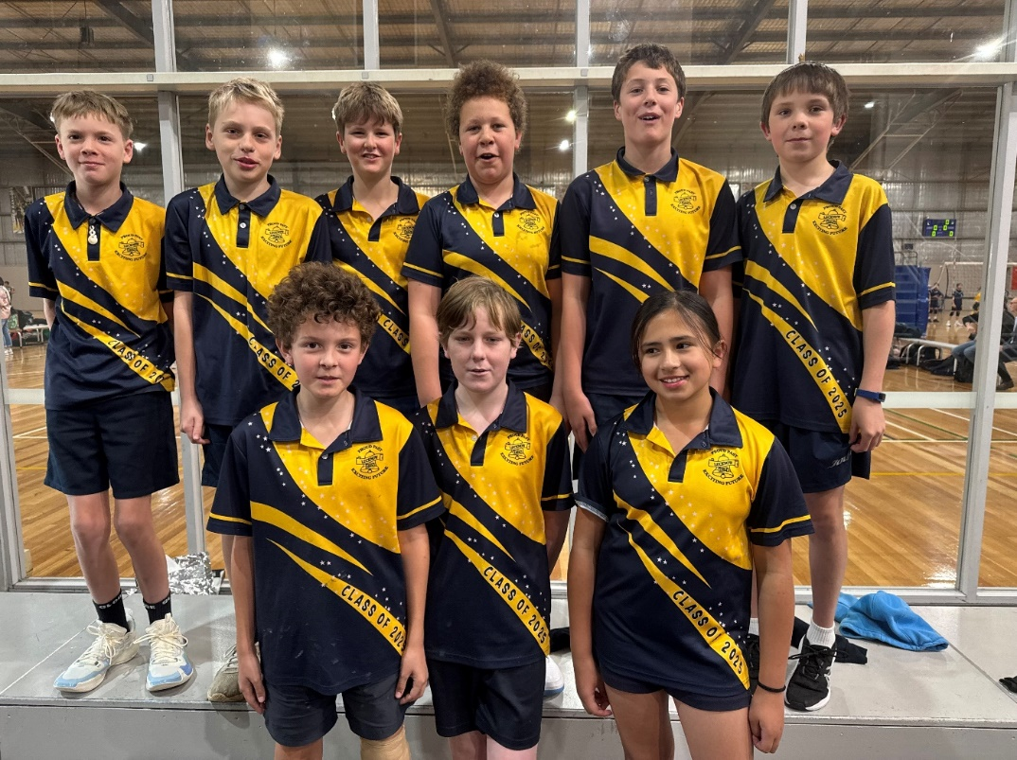

STUDENT REPORTS
As we shift to the Victorian Curriculum 2.0 for English, families will see some small changes in this semester’s reports. The “I can” statements in English and Mathematics have been thoughtfully reduced to a more focused selection.

This is designed to make the reports clearer and easier to interpret, while rest assured that teachers still consider all areas of the curriculum when making judgements about student learning.

The report will include the following:
- A personal comment in relation to your child’s learning behaviours and social skills.
- A summary of the concepts learnt in Numeracy (Maths) and Literacy (Reading, Writing and Speaking and Listening).
- A summary of the concepts learnt in specialist classes (Visual Art, STEM, Physical Education, Library & Music and Culture).
- Student performance marked against I can statements for the relevant level in Reading, Writing, Number & Algebra and specialist subjects.
- Work habits will be marked against behaviour, effort, work quality, task completion and respect for others.
- Teacher judgement scores.
- Student self-reflection.
These reports will be made available to download via uEducateUs on Friday 12th December.

If you would prefer a hard copy print out of your child’s report, you must return the below slip by Friday 5th December.

Emily Forbes – Assistant Principal

FORM TO REQUEST HARD COPY PRINT OUT OF STUDENT REPORT (SEMESTER 2).
Must be handed in by Friday 5th December.

PARENT NAME: __________________________________________________________

STUDENT/S NAME: ________________________________________ GRADE: _______

________________________________________ GRADE: _______

________________________________________ GRADE: _______

________________________________________ GRADE: _______

JUNIOR SCHOOL COUNCIL
What our JSC kids have thought about being in JSC this year.

“I like JSC because thinking about what we are going to do. And my favourite thing was counting the money and talking to each other.”
Annabelle 34B

“I like JSC because… the fundraisers like crazy hair day and casual clothes day. Guessing how much money we raised. I liked getting my badge.”
Addi and Sammy 12D
“I liked going to the meetings and raising money to help people in need, and the satisfying noise of the money counter. I loved JSC, I would definitely do it in 2026!”
Emily 3CT
“JSC comes up with all these ideas, I love JSC because I like coming up with fundraiser activities. I love JSC because I like counting money”
Bridie 2NT
“I liked when I was a JSC Rep because we came up with cool things. I liked PJ day because we got to see different pj’s”
Bridie 1CW
“I liked the money counting and fundraising”
Levi 6LS
“I liked how we counted the money and learn about the people we were raising money for.”
Max 5DC
“I liked JSC because I got to organise fundraisers and see all the ideas and know early about fundraising.”
Taya 6LS
“I love JSC because JSC comes up with great ideas.”
Eva 2NT
“Being a JSC rep has been an amazing experience to learn about how to fundraise and about the people who we’ve been fundraising for. Another thing I have enjoyed was getting to choose what we are doing.”
Aster 6SF
“I loved all the fun stuff and we got ideas! And counting the money we were excited to see the amount go up. DO IT NEXT YEAR!. Thank you!”
Maddy 5CM
“I loved being in Junior School Council because I got to do Crazy Hair Day and count the money we fundraised”
Harry 1ES
“I liked doing all the money counting for all the fundraisers and learning about where the money was going and that it was going to a good spot to help people that were in need. I would definitely do it again next year but I’m going into secondary school so I won’t be able to.”
Levi T 6CM
“ I have loved planning all the activities and seeing the school in their pyjamas and in casual clothes day and also crazy hair day. It was fun being a JSC .Another thing I have loved is counting all the money we have raised on PJ day and casual clothes day.”
Piper 3AG
“I loved when Ms Pendergast said Arlo and Sam because we were so excited”
Arlo 2MP
“As a representative I loved organising all the fundraisers, I loved the experience as well. Another thing I enjoyed was helping out all the little kids as well.”
Bai 6CM
“I loved JSC because JSC is fun and I loved when I got picked and I love it so much I want to do it next year.”
Sam 2MP
“This year has been great being on JSC. Our fundraisers have brought lots of joy and creativity. Throughout the year we have raised lots from “Do It for Dolly day” and crazy hair day and Pyjama Day. I hope I can do it next year.”
Bonnie 5CM
“ I have enjoyed getting to help think of Fundraising ideas and seeing all of the money we’ve raised is fantastic because we donate all the money to charities”
Ella 6SF

“I liked the fundraising and counting the money and the fundraisers.”
James 45W

LUCKNOW PRIMARY SCHOOL CHRISTMAS CONCERT

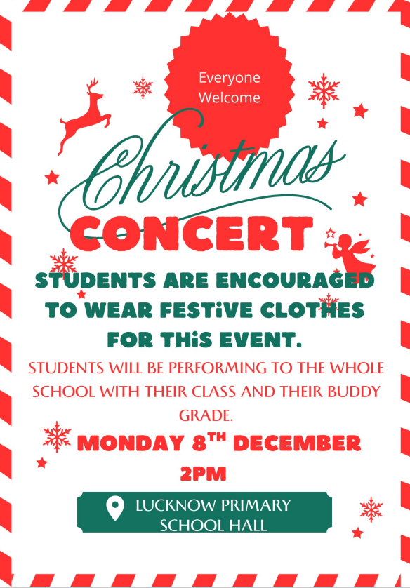


LUCKNOW’S LEARNING LEGENDS
Week
7 & 8

Class | Student
PAS | Georgie for the constant commitment and dedication she shows towards all her learning. She always puts in her best effort and achieves some wonderful results. Well done Georgie!
PEM | Imogen for your outstanding efforts when reading! You have been trying your absolute best when sounding out and tackling unfamiliar words. Well done!  Noah for being a kind and caring member of PEM. You consistently show respect when interacting with your peers and teachers. Well done, Noah!
PMB | Nevaeh, it is great to see you are showing determination and focus on your learning and working hard to complete tasks. Great work superstar!
PVG | The whole class for a great year of learning. You should be very proud of yourselves!
1CW | Liam, well done for building your writing stamina. It has been lovely to read more of your creative writing pieces, and you have been working hard to improve your handwriting as well.  Layla for working hard during our writing sessions this week. You have been vey focussed completing some wonderful letters. Well done, Layla!
1ES | Maive for her consistent positive attitude in always having a go even when things are challenging. It’s been great to see you working your way out of the ‘Learning Pit’.
1MW | Harrison for thinking outside the box during Problem Solving. You love to challenge yourself with big numbers. Well done.  Lottie for showing amazing learning behaviours the last week. You have been super focused and respectful. Keep it up, Lottie!
12D | Logan for always showing excellent teamwork skills and being a good friend to others. Well done Logan!  Liev for working hard on his persuasive writing piece about why schools should have a longer lunch break. Great job Liev!
2JS | Iyah for brightening our classroom everyday with her positive attitude and kindness. You're an amazing friend to everyone and we are so lucky to have you in 2JS.  Terrence for your positive and hardworking attitude. You should be very proud of all your achievements this year, well done!  Kayden for coming to school everyday with a smile and positive attitude. Well done for your improved focus this term, keep it up!
2MP | Charlotte for having such a positive attitude to learning. She tries so hard and never gives up no matter what challenges we give her. We're so glad you're back in our class Charlotte!  Chase for his fantastic efforts in Writing. We've thoroughly enjoyed reading your narratives and persuasive texts Chase. Keep it up!
2NT | Thea for demonstrating incredible growth in reading accuracy and comprehension. Keep up the outstanding work, Thea!  Cooper, you have been working hard to uplevel your word choice in your writing pieces, keep up the awesome work Cooper!  Eva for always being a helpful and caring member of our class. Thank you Eva, we are so lucky to have you!
3AG | The whole Class for being amazing while on camp. Thank you for such a fun 3 days together!
3CT | All of 3CT for working together so we had a wonderful camp filled with amazing experiences.
34B | Mischa, your dedication to improving your reading and eagerness to seek feedback is outstanding. Akyrah, you consistently demonstrate our school values in everything you do. Well done to both of you!
34M | Nate, your acting skills during our performance unit was outstanding. You express great character emotions, and you showed great confidence and team-work in your script-writing, your rehearsals, and your performance.
34R | Chelsea & Olivia for being awesome at showing our school values every day. Your kind, helpful, and always trying your best. Thanks for being such a positive part of our class!
4JW | Sonny for showing resilience towards his learning throughout the year, keep it up Sonny!
45W | Ollie for always bringing a cheerful, happy smile into the classroom everyday.
5CM | Charlotte for the significant effort she puts into improving her learning in all areas. You are a superstar Charlotte with a positive mindset and great attitude towards school.
5DC | Zara & Paige for embracing the school values and trying their best in every task they undertake, you girls are absolute superstars!
56I | Jack for teaching some junior students how to kick a footy!  Sofia for your improved dedication toward your learning this semester. Keep up the great work!
6CM | Winston, Lachie and Declan for being barbecuing ninjas during the canteen project!  Amaya for an absolutely stellar year. Awesome work!
6LS | Taya for her published emotive writing highlighting the devastation of war. Well done Taya.
6SF | Amelia for always putting 100% effort into her work and for being a self-directed learner. A fantastic achievement, Amelia.
Principal’s Award | Yaraki from 3AG for consistently showing our school values and being an all-round top person! She received several staff shout-outs for the way she conducted herself on Year 3 camp—always eager to have a go and wonderful at supporting her peers. Well done, Yaraki, you’re a star!

OPEN AFTERNOON LEARNING CELEBRATIONS

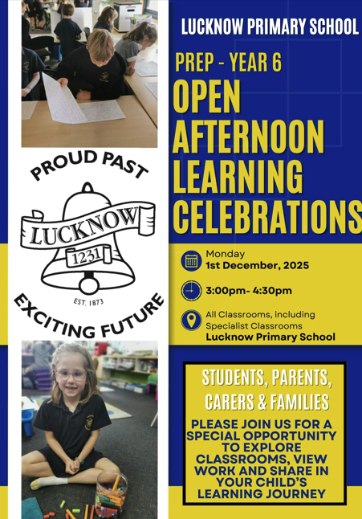

BOOK CLUB
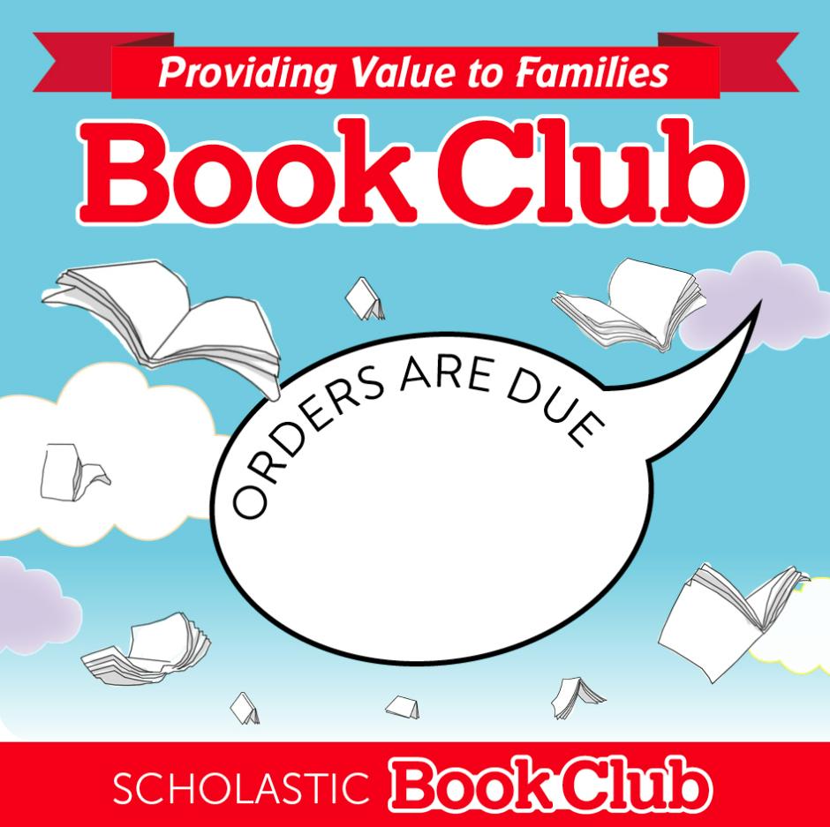
FRIDAY 28th NOVEMBER


COMMUNITY NEWS
Save the Outdoor Pool – We Need Your Voice!
Our local community is rallying together to keep the Bairnsdale Outdoor Pool open, and we encourage all families to lend their support. The outdoor pool is an important space for our children to be active, learn water safety, and enjoy time outdoors with friends and family.

This Saturday, 29th November, join the community at the rotunda on Main Street at 10am to help show your support to save our pool.

